Week 1 - Grasping the context

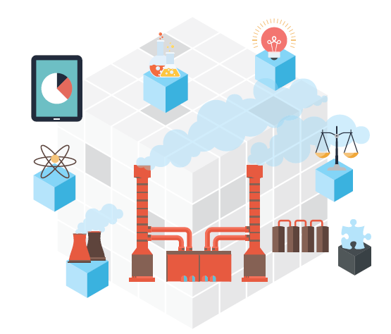

Class: e-PO5

Name: David Hooi  
Studentnumber: 3587460

Name: Jerique Hodge  
Studentnumber:

Date: 14-04-2016  
Version 1.1

Contents

Introduction 3

Overview assignment(s) week 1 4

The business case 5

Requirements gathering 6

Analysing the requirements 7

Visualizing the process 8

# Introduction

In Fundamentals for ICT Students (block) 2 you will work on a project that will cover all 3 streams! This week we’re going to have a look at ICT & Business and how it fits in realizing an IT solution.

One of the tasks of a ICT & Business expert is to determine what kind of business problems there are and how to solve those using IT. Besides solving a problem, finding opportunities to improve a business process (via an IT solution) is what makes you a valuable asset to the project. This skillset is also useful for non ICT & Business students/professionals.

The structure of this week’s practical will be as following:

* Read the case and discuss what the client is actually asking you to create;
* Breakdown the deliverables into requirements;
* Discuss 'weight' and prioritize the requirements.

## Overview assignment(s) week 1

**Deliverable:** This document with the answers.  
**Deliverable per**: 2 Students.  
**Deadline:** Before week 3.

As a preparation a business case is proposed. As interviewing will be covered at another course you will get a summarized transcript representing a business case. It’s up to you to determine what is really need so we don’t end up as the situation below:

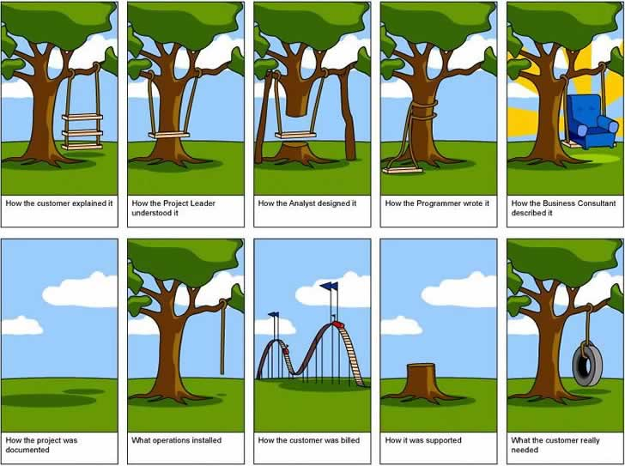

Figure 1: Project gone wrong

# The business case

Your group represents a company who is asked to implement a proof of concept for their warehouse. One of your representatives conducted an interview with the client mr. J. Doe. The following text is a summary of the transcript of the interview*:*

*I want a proof of concept to show the CEO it’s a good investment to automate a part of our warehouse logistics with an AGV following a predefined path. This proof doesn’t need to be a real AGV, but something like a robot made in Lego Mindstorms is enough.*

*I want the AGV to be able to follow a track like figure 2. It should be able to go to the pickup area to get a container and then transport it to the drop-off area to drop it off. It would be nice to have the AGV to automatically return to the start position, but we’re not sure yet how that part of the track will look like.*

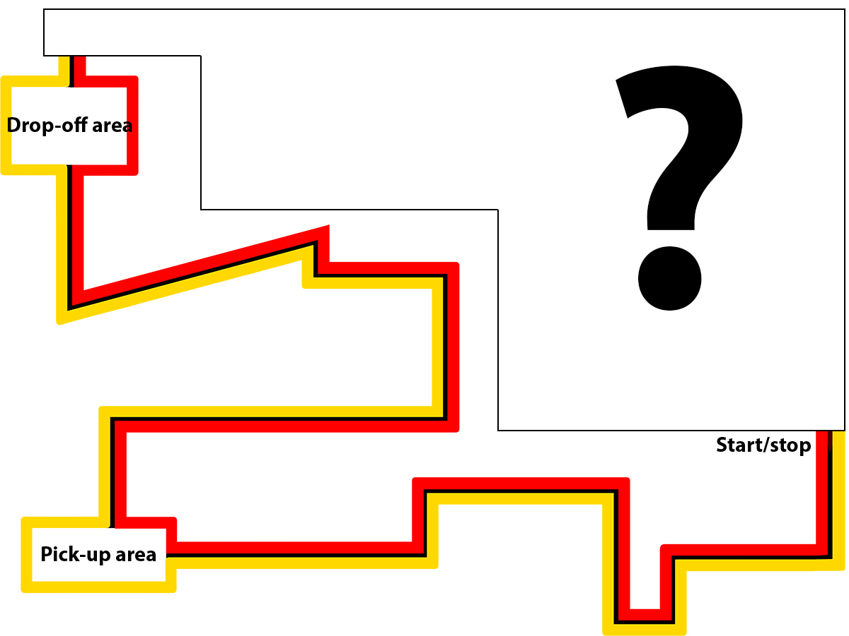

Figure 2: Predefined track though warehouse

*The actually AGV should be able to pick up a container that can weight up to 500kg. The content of the container varies per order we’re processing. It could be simple things like golf balls to heavy bowling balls. Obviously they are not as fragile as glass, but nonetheless they can be damaged if they are dropped. So it’s a bad thing if the AGV where to drive of a platform!*

*It would be nice if the AGV will be streamlined and aerodynamic minimizing the time it takes to pick-up and drop-off the container. Obviously it should not hit employees, other AGVs or machinery because of some sort of (speed) error. Some sort of emergency break is actually mandatory.*

*As mentioned we actually process different kinds of orders and it’s not set at which times the AGV should start the automated delivery. Only a packing employee knows when to start the delivery. This employee has a computer at his disposal and it would be good to see some kind of status update about what the AVG is doing. So the employee should be able to start the automated process via the predefined path, pause/resume and see the status.*

*Any extra features you can come up to convince the CEO would be greatly appreciated.*

# Requirements gathering

Mr. Doe actually had a clear view of what he wants and your representativeonly had to ask questions about some specific things like workload, exceptions, etc. Obviously in a real life situation this is not always the case.

As an ICT & Business student you will be the person who needs to communicate with the involved parties (called stakeholders) to gather the requirements. This can be done in different ways like:

* (Online) survey;
* Shadowing an employee;
* Interview;
* Etc.

The method your representative used was interviewing. Can you, based on the summary of transcript, determine what the client actually wants? Is it an AGV (look up AGV if you do not know what it is) or something else?

Discuss with each other what the actual deliverables are and what features are actually asked. Put the findings of your discussion in the table below.

Writing down per deliverable: the deliverable itself and which features are requested for it.   
**NOTE:** The features should be specified as bullet points and be specific. Something like: “it should have a remote control feature” is not good enough, but “it should have a remote control feature which can do X, Y and Z” is what is expected!

|  |  |
| --- | --- |
| Deliverable | Requested features |
| Able to follow track  Pick up a container that can weight up to 500kg ,Drop containers off  Able to move and  Transport containers  Stay on platform and  Not hit employees , other AGV  Machines or other obstacles  Has emergency break  Display information to employee and  can be started, paused and resumed and see the status by the employee  return to starting position automatically | It should have cameras on it so that it can use them to follow a red or yellow track by distinguishing the red or yellow track as the path and moving along that  It should have a grabber feature on it that can pick up containers that weight up to 500kg and drop containers  It should have a moving feature that allows it wheels to move forward or backward and also move its wheels forward or backward while it is holding a container  It should have sensor feature that allows it to sense the area around it for any humans, other AVGs or other obstacles in order to avoid falling off of the platform and collision  It should have an emergency break that stops movement when a activated or when something deemed an emergency has occurred  It has a application feature that allows it to be started(start the automated process via the predefined path), resumed(resume movement) or paused(stop movement) by the employee via an program and also displays status updates about what the AVG is doing to the employee  It has a return home feature that saves a position as home and allows the AVG to return back to that position |
|  |  |

# Analysing the requirements

From a client’s perspective everything should be implemented and is important, but in reality no requirement is equal to another. As an ICT expert you will be asked to take a look at the requirements and give your opinion about how feasible (and important) it is and also judge how much time it would take to implement it.

In the coming weeks you’re actually going to prepare and at a certain point start implementing the deliverables asked by mr. Doe. Let’s have another look at the requested features and this time think about how they could be implemented.

**NOTE**: It’s really hard to think about how something needs to be implemented if you’ve never done it before. If the ‘problem’ is too big to think of a way you should try to split it up in smaller/more comprehensible pieces.

Determine with each other:

* How important it is compared to the other features;
* How much time would it take to implement compared to the other features.

Put it in the table below. Place the most important feature at the top and the least important at the bottom. In the column ‘*Implementation time (%)*’ write down what percentage of your time would go into implementing it.

|  |  |  |
| --- | --- | --- |
| Deliverable | Requested features | Implementation time (%) |
| Able to move and  Transport containers  Able to follow track  Stay on platform and  Not hit employees , other AGV  Machines or other obstacles  Has emergency break  Pick up a container that can weight up to 500kg ,Drop containers off  Display information to employee and  can be started, paused and resumed and see the status by the employee  return to starting position automatically | It should have a moving feature that allows it wheels to move forward or backward and also move its wheels forward or backward while it is holding a container  It should have cameras on it so that it can use them to follow a red or yellow track by distinguishing the red or yellow track as the path and moving along that  It should have sensor feature that allows it to sense the area around it for any humans, other AVGs or other obstacles in order to avoid falling off of the platform and collision  It should have an emergency break that stops movement when a activated or when something deemed an emergency has occurred  It should have a grabber feature on it that can pick up containers that weight up to 500kg and drop containers  It has a controlled feature that allows it to be started(start the automated process via the predefined path), resumed(resume movement) or paused(stop movement) by the employee and also displays status updates about what the AVG is doing to the employee  It has a return home feature that saves a position as home and allows the AVG to return back to that position | 20  15  30  5  20  5  5 |

# Visualizing the process

You should now have a good idea of what needs to be created and have written it down in text. As the phrase ‘a picture is worth a thousand words’ indicate, a visualization makes things easier to grasp.

There are actually different ways of visualizing text. Depending on what you want to visualize it could be a comic or perhaps an awesome drawing of an AGV.

With this last assignment you need to visualize the steps/processes that the proof of concept need to take for the automated delivery process of a container. In practice professions tend to make (business) process diagrams/models to visualize how a process works. If you search for this term you will see different examples like:

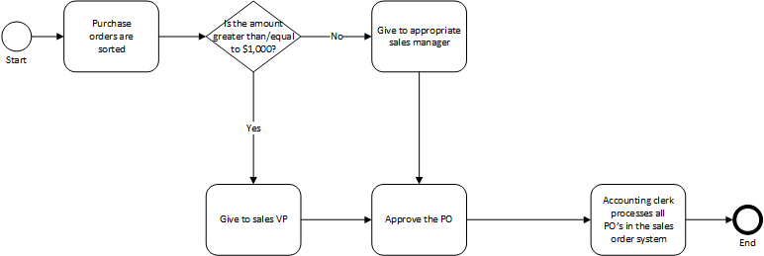

Figure 3: Example business process diagram 1

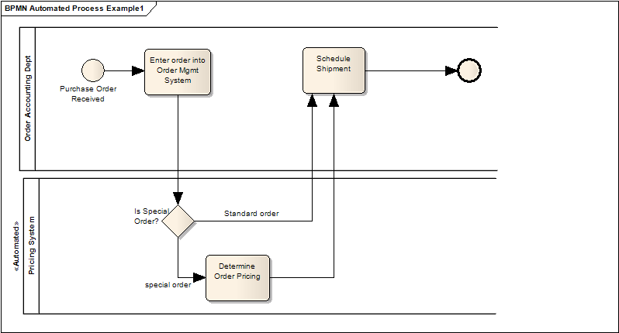

Figure 4: Example business process diagram 2

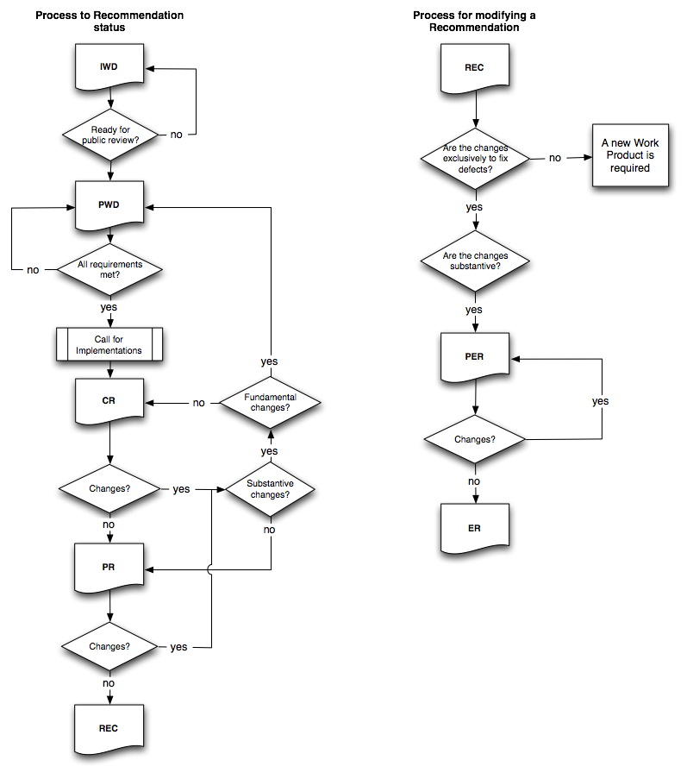As you can see there are some variations of visualizing processes, but they all have common denominators. The diagrams are all visualized as a flow chart/decision tree containing the following elements:

Figure 5: Example business process diagram 3

* Start & end point(s);
* Arrows indicating the flow/order;
* Steps/blocks in the process;
* Decision points;

Depending on the stream you choose you will get more theory about how such diagram needs to be created. For now you can decide together which way you prefer.

On the next page you can find an area where you can draw or include an image/photo for the visualization you created about the delivery process.

|  |
| --- |
| D:\Download\My First Document.png |